Smart dashboard installation:

Pre-Intallation procedure:

Before you install the Smart dashboard to the client’s computer make sure to install the following:

1. Latest version of Xampp

After successfully installing Xampp Control panel. Next you will need to install the Cacert.pem file:

1. Go to: <https://curl.haxx.se/ca/cacert.pem>
2. Right click on the webpage, then click on “save as”.
3. Go to the following directory:

C:\xampp\php

And click “Save”.

1. Select the computer Windows button, then open the Control Panel to the highlighted area in the image below:

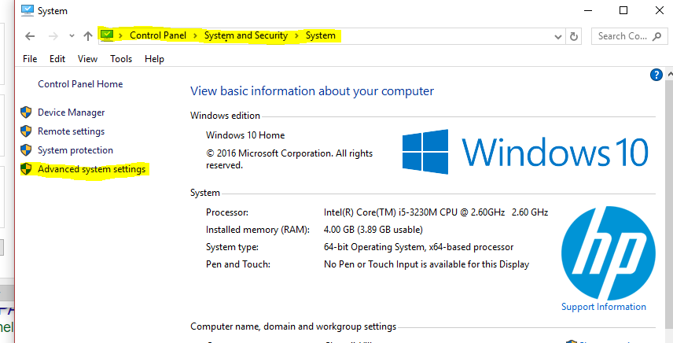

Select Advanced System Settings.

1. Select the “Advanced” tab and then select “Envirnoment Variables”.

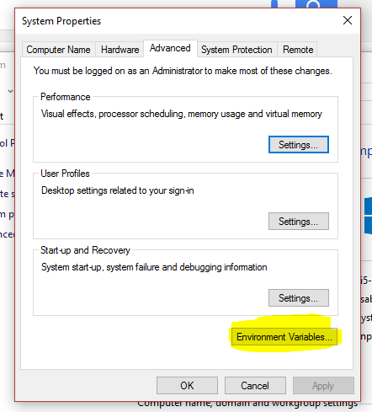

1. In the Dialog box select “Path” under the “System Variables” area then select “Edit” shown in the image below.

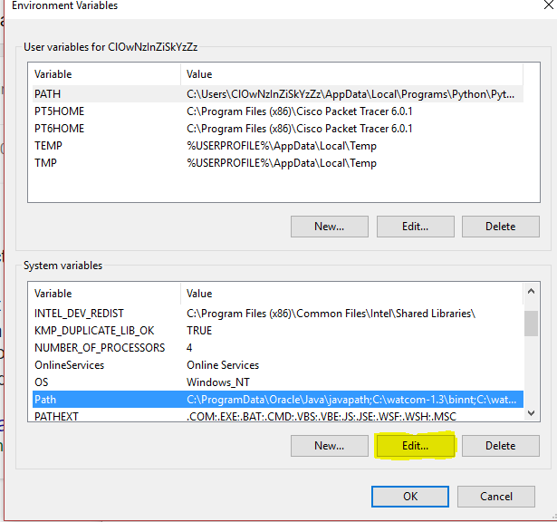

1. In the new dialog box select “New” and enter the following path shown highlighted in the image below then click on “OK” :

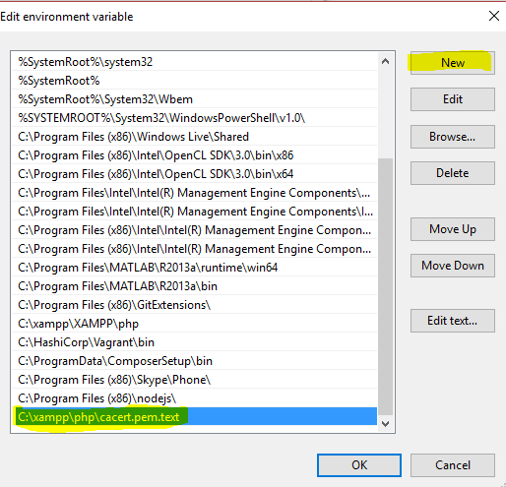

1. Run the Xampp control panel and then config then click on PHP (php.ini) as shown in the image below.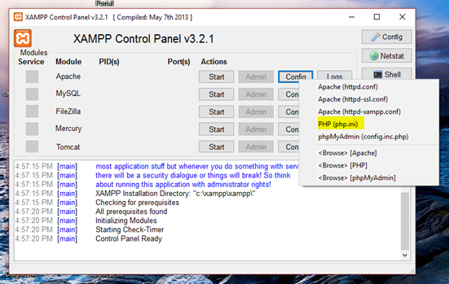
2. Enter the following highlight information in the image below as is then save the document and close it:

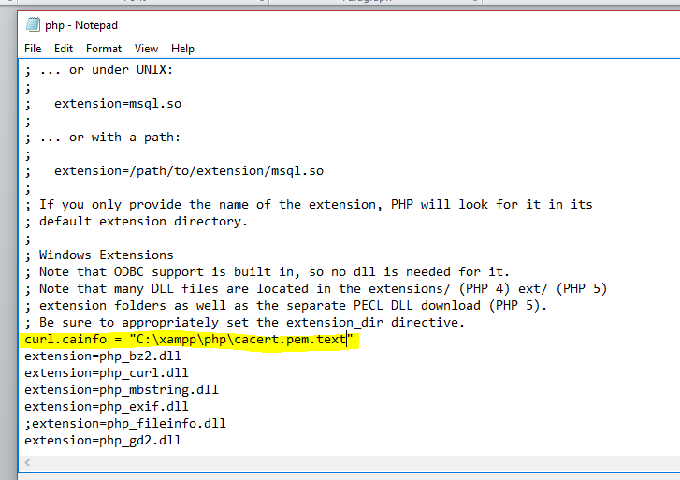

Installing Smart dashboard Database:

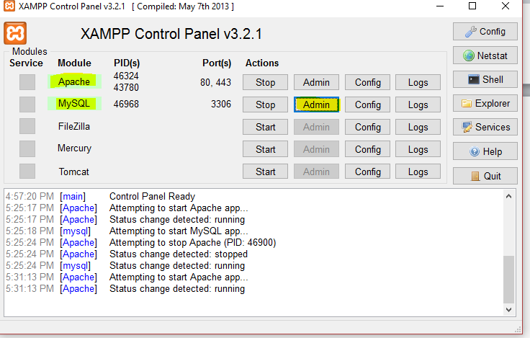

Select the database that was previously created and then select the “Import” tab



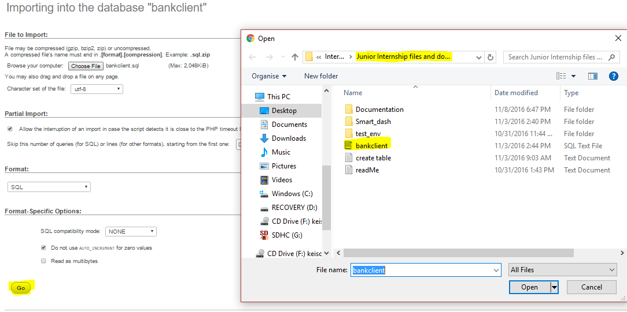

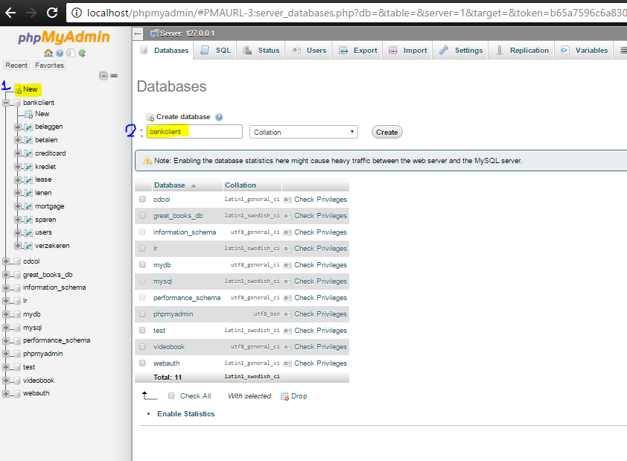

Installing the Smart dashboard files and running the application:

In the 